Bioinformatics Algorithms – Online Tool
Use Case Model

Version 0.01

Document history

Date | Version | Description | Author
10/28/2016 | 1.0 | Tool that will provide bioinformatics algorithms for processing of biological data and some other techniques as mapping of the genes and similar. | Medina Colic

Contents
1 Introduction 4
1.1 Purpose of this document 4
1.2 References 4
2 Use Case Diagram 5
3 Use Case Details 6

Introduction

Purpose of this document
This document provides a coherent view of the Use Cases and Actors of the system as well as the system boundaries. The Use Cases are weighed and prioritized.

References
- Project Idea Proposal
- Project Topic Form
- User Stories
- StakeHolders Questionnaire

Use Case Diagram
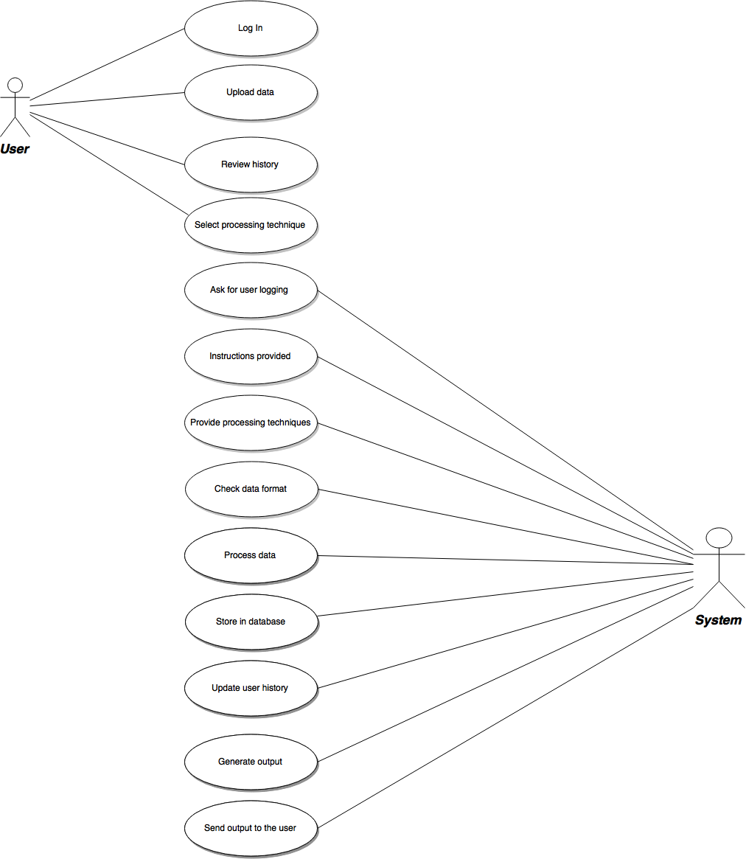

Use Case Details

Use Case Name: | Log In
Created By: | Medina Colic |  | Last Updated By:
Date Created: | 10/29/2016 |  | Last Revision Date:
Actors: |  | User
Brief Description: |  | User provides its user data (email, etc.) and system creates its account.
Triggering events: |  | User wants to use a tool
Related Use cases: |  | Might review the activity history
Pre-conditions: |  | System up and running  Account information should be ready
Post-conditions: |  | User account created  User email address stored
Flow of Activities: |  | User |  | System
 |  | - User wants to use the online tool and enters name, surname and email address.  - User confirms the entered data. |  | 1.1 System creates a new user account.  1.2 System returns user entered information and asks for confirmation of it.  2.1 System stores the user data in the database
Exception Conditions: |  | - User data incomplete.  - User email address isn’t valid.

Use Case Name: | Upload data
Created By: | Medina Colic |  | Last Updated By:
Date Created: | 10/29/2016 |  | Last Revision Date:
Actors: |  | User
Brief Description: |  | User uploads it data for processing.
Triggering events: |  | User needs processed data
Related Use cases: |  | Wants to calculate GC percent of its data and/or other biological features.
Pre-conditions: |  | Created user account  Data in format that system accepts
Post-conditions: |  | Data uploaded for processing
Flow of Activities: |  | User |  | System
 |  | 1. User wants to upload data |  | 1.1 System checks if the data format is compatible with data formats it accepts.  1.2.1 If yes, proceed to select the features you want to use  1.2.2 If no, upload a valid data format.
Exception Conditions: |  | Wrong data format.

Use Case Name: | Review history
Created By: | Medina Colic |  | Last Updated By:
Date Created: | 10/29/2016 |  | Last Revision Date:
Actors: |  | User
Brief Description: |  | User reviews previous activities performed using the tool.
Triggering events: |  | Wants to recall previous data and information.
Related Use cases: |  | Don’t want to calculate or process something again, so recalling it from the history of activities is easier for a user.
Pre-conditions: |  | Previous activities.
Post-conditions: |  | List of activities user has completed using the tool.
Flow of Activities: |  | User |  | System
 |  | 1 Requests to review the activities history |  | 1.1 System locates the user account in database and pulls all activities synchronized with that user
Exception Conditions: |  | No previous activities.

Use Case Name: | Select processing technique
Created By: | Medina Colic |  | Last Updated By:
Date Created: | 10/29/2016 |  | Last Revision Date:
Actors: |  | User
Brief Description: |  | User should select which features of the tool or which processing technique it wants to use.
Triggering events: |  | Wants to analyze or process biological data.
Related Use cases: |  | Selecting which feature to use.
Pre-conditions: |  | Created account.  Ready valid data format.
Post-conditions: |  | Selected technique.  Ready to submit for processing.
Flow of Activities: |  | User |  | System
 |  | 1. Selects the feature or processing method |  | 1.1 Once again confirms the data format  1.2 Process the data
Exception Conditions: |  | Not valid data format.

Use Case Name: | Ask for user logging
Created By: | Medina Colic |  | Last Updated By:
Date Created: | 10/29/2016 |  | Last Revision Date:
Actors: |  | System
Brief Description: |  | System asks for user logging in order to allow full access.
Triggering events: |  | Users prompt to use the tool
Related Use cases: |  | User wants to use the full features of the tool.
Pre-conditions: |  | Up and running system.
Post-conditions: |  | User logged in.  All features available.
Flow of Activities: |  | System |  | User
 |  | 1. Provide the log in information |  | 1.1 User provides log in information
Exception Conditions: |  | Not valid user log in information.

Use Case Name: | Instructions provided
Created By: | Medina Colic |  | Last Updated By:
Date Created: | 10/29/2016 |  | Last Revision Date:
Actors: |  | System
Brief Description: |  | Provides instructions how to use the tool.
Triggering events: |  | Users prompt to use the tool
Related Use cases: |  | For easier and quicker usage of the tool, instructions are provided by the system.
Pre-conditions: |  | Up and running system.
Post-conditions: |  | Instructions provided
Flow of Activities: |  | System |  | User
 |  | 1. Provides the instructions how to use the tool |  | 1.1 User reads the instructions and benefits from the tool.
Exception Conditions: |  | User is a beginner and struggles with understanding the instructions provided.

Use Case Name: | Processing techniques
Created By: | Medina Colic |  | Last Updated By:
Date Created: | 10/29/2016 |  | Last Revision Date:
Actors: |  | System
Brief Description: |  | Bioinformatics algorithms on which the tools is running and performing the processing techniques available to the user.
Triggering events: |  | Users prompt to use the tool
Related Use cases: |  | Features have biological significance, generated by expert biologist and computer programmers.
Pre-conditions: |  | Up and running system.  Written bioinformatics algorithms.
Post-conditions: |  | Features ready to be used by the user.
Flow of Activities: |  | System |  | User
 |  | 1. Bioinformatics algorithms on the front end, responsible for processing the data |  | 1.1 User selects the processing techniques and triggers the algorithms, which is responsible for it.
Exception Conditions: |  | Large data.  Incorrect method for a provided data.

Use Case Name: | Check data format
Created By: | Medina Colic |  | Last Updated By:
Date Created: | 10/29/2016 |  | Last Revision Date:
Actors: |  | System
Brief Description: |  | A check if the data format provided as user’s input is competent with the formats system allows.
Triggering events: |  | Users prompt to use the tool
Related Use cases: |  | Suitable data format for further processing.
Pre-conditions: |  | Up and running system.
Post-conditions: |  | Ready to process the data
Flow of Activities: |  | System |  | User
 |  | - If data provided is in correct format proceed to select your processing technique  - If not, please upload the data in a correct format |  | - Users provides the input data  - Correct data  2.1 Incorrect data
Exception Conditions: |  | Not valid user log in information.

Use Case Name: | Process data
Created By: | Medina Colic |  | Last Updated By:
Date Created: | 10/29/2016 |  | Last Revision Date:
Actors: |  | System
Brief Description: |  | After user selects processing technique, system applies it on the input data.
Triggering events: |  | Users prompt to use the tool
Related Use cases: |  | Using the tool’s features.
Pre-conditions: |  | Up and running system.  Selected processing method.
Post-conditions: |  | Processed data.  Ready to be stored in output file.
Flow of Activities: |  | System |  | User
- Matches the input data and selected method.
- Applies the method.
- Stores the output
Exception Conditions: |  | If data is large processing might take time or the system might crash.

Use Case Name: | Store in database
Created By: | Medina Colic |  | Last Updated By:
Date Created: | 10/29/2016 |  | Last Revision Date:
Actors: |  | System
Brief Description: |  | After processing data store it in database
Triggering events: |  | Users prompt to use the tool and receive the output.
Related Use cases: |  | Storing the result data so user can recall it later on.
Pre-conditions: |  | Up and running system.  Selected processing method.  Completed processing.
Post-conditions: |  | Processed data.  Stored in the database.
Flow of Activities: |  | System |  | User
 |  | - Stores the result data in the database |  | 1.1 When recalling the activities history can easily access it again.
Exception Conditions: |  | If data is large processing might take time or the system might crash.

Use Case Name: | Update user history
Created By: | Medina Colic |  | Last Updated By:
Date Created: | 10/29/2016 |  | Last Revision Date:
Actors: |  | System
Brief Description: |  | Updates the activities history after every new activity user does within the tool
Triggering events: |  | User’s new activity.
Related Use cases: |  | User activities stored in case user wants to recall them.
Pre-conditions: |  | System up and running.  Performed user activities
Post-conditions: |  | Updated list of user activities after every new activity
Flow of Activities: |  | System |  | User
- Stores the user activities in a stack
- Every new user’s activity is at the top of a stack
Exception Conditions: |  | Miss the activity update in case of internet cut-off

Use Case Name: | Generate output
Created By: | Medina Colic |  | Last Updated By:
Date Created: | 10/29/2016 |  | Last Revision Date:
Actors: |  | System
Brief Description: |  | System collects the generated/processed data from database and stores it in a file, ready to be sent to the user.
Triggering events: |  | Finishing the processing.
Related Use cases: |  | Bring the result from database and store it to the file.
Pre-conditions: |  | Up and running system.  Finished processing method
Post-conditions: |  | Results stored in a file.
Flow of Activities: |  | System |  | User
- Collects the results from database
- Stores it into a file
Exception Conditions: |  | Too large data.

Use Case Name: | Send output to user
Created By: | Medina Colic |  | Last Updated By:
Date Created: | 10/29/2016 |  | Last Revision Date:
Actors: |  | System
Brief Description: |  | Generated output is sent to user’s email.
Triggering events: |  | Finishing the data processing.
Related Use cases: |  | Share the result data with user
Pre-conditions: |  | User information in database.  Email information provided on user’s profile.
Post-conditions: |  | Results sent to the user.
Flow of Activities: |  | System |  | User
 |  | - Is it your email address? (email address from user’s profile)  - If yes, it is sent.  If no, please enter the new email address on which you would like to receive your results. |  | - User answers yes or no.
Exception Conditions: |  | Not valid user email address.

